Department of Government Enablement, Oracle Cloud Implementation

OIC Technical
Standards and Guidelines

Document Control Information
Document Information
Document Identification | OIC Standards and Guidelines
Document Name | Department of Government Enablement - OIC Technical Standards and Guidelines
Project Name | Department of Government Enablement, Oracle Cloud Implementation for Abu Dhabi, UAE
Client | Abu Dhabi, Department of Government Support
Document Author | Deloitte
Document Version | V1.0
Document Status | Final
Date Released | 21-Mar-2024
Document Edit History
Version | Date | Additions/Modifications | Prepared/Revised by
0.1 | 21-Mar-2024 | Initial Draft | Nikita Patel
1.0 | 22-Mar-2024 | Final Version | Anoop Salian
1.1 | 03-Jun-2024 | Updated Naming Standards | Jaskaran Chawla
Document Review/Approval History
Date | Name | Organization/Title | Comments
22-Mar-2024 | Anoop Salian | Deloitte/Manager | Reviewed
Distribution of Final Document
The following people are designated recipients of the final version of this document:
Name | Organization/Title
<Name> | <Organization/Title>

Contents
Contents 3
1 Introduction 4
1.1 Purpose 4
1.2 Scope 4
1.3 Audience 4
1.4 Terms and Definitions 4
1.5 Module Abbreviations 5
2 Standards and Guidelines 6
2.1 OIC 6
2.1.1 SFTP Folder Structure 6
2.1.2 Naming Standards 7
2.1.3 OIC Integration Design Basic Guidelines 12
2.1.4 High Volume Design Considerations 13
2.1.5 Error Handling Guidelines 14
2.1.6 Common Integration User 14
3 Open and Closed Issues 15
3.1 Open Issues 15
3.2 Closed Issues 15

Introduction

Purpose
This document describes the design and development standards for implementation of Oracle ERP Cloud & OIC Applications for Department of Government Enablement (DGE), Project. These standards assist high quality, portability across multiple platforms, consistency, ease of maintenance, and compatibility with other Oracle products.

Scope
This document is intended to govern the naming conventions and coding standards and primarily affect tasks in the Design, Build and Testing phases. This document is not a training guide, and it is understood that developer will need to understand the technology/tools.

Audience
The target audience for this deliverable will be primarily the designers, developers and architects of technology solutions related to Oracle ERP cloud and related systems.

Terms and Definitions
Term | Definition
DGE | Department of Government Enablement
API | Application Programming Interface
BI | Business Intelligence
DB | Database
ERP | Enterprise Resource Planning
ESS | Enterprise Scheduling Service
FBDI | File-Based Data Import
FTP | File Transfer Protocol
OIC | Oracle Integration Cloud
OTBI | Oracle Transactional Business Intelligence
PaaS | Platform as a Service
PII | Personally identifiable information
REST | Representational State Transfer
RICE | Reports, Interfaces, Conversions, Extensions
RTF | Rich Text Format
SaaS | Software as a Service
SFTP | Secure File Transfer Protocol
SOAP | Simple Object Access Protocol
SR | Service Request logged with Oracle
Web Service | Web-based API’s
XML | Extensible Markup Language

Module Abbreviations
Abbreviation | Module
AP | Accounts Payable
AR | Accounts Receivable
GL | General Ledger
FA | Fixed Assets
CM | Cash Management
EX | Expenses
PO | Purchasing
INV | Inventory
OM | Order Management
PA | Projects

Standards and Guidelines

OIC
This section provides general guidelines and naming standards for OIC Connections, Integrations, lookups, users etc.

SFTP Folder Structure
The following folder structure will be created in the SFTP for supporting proper identification
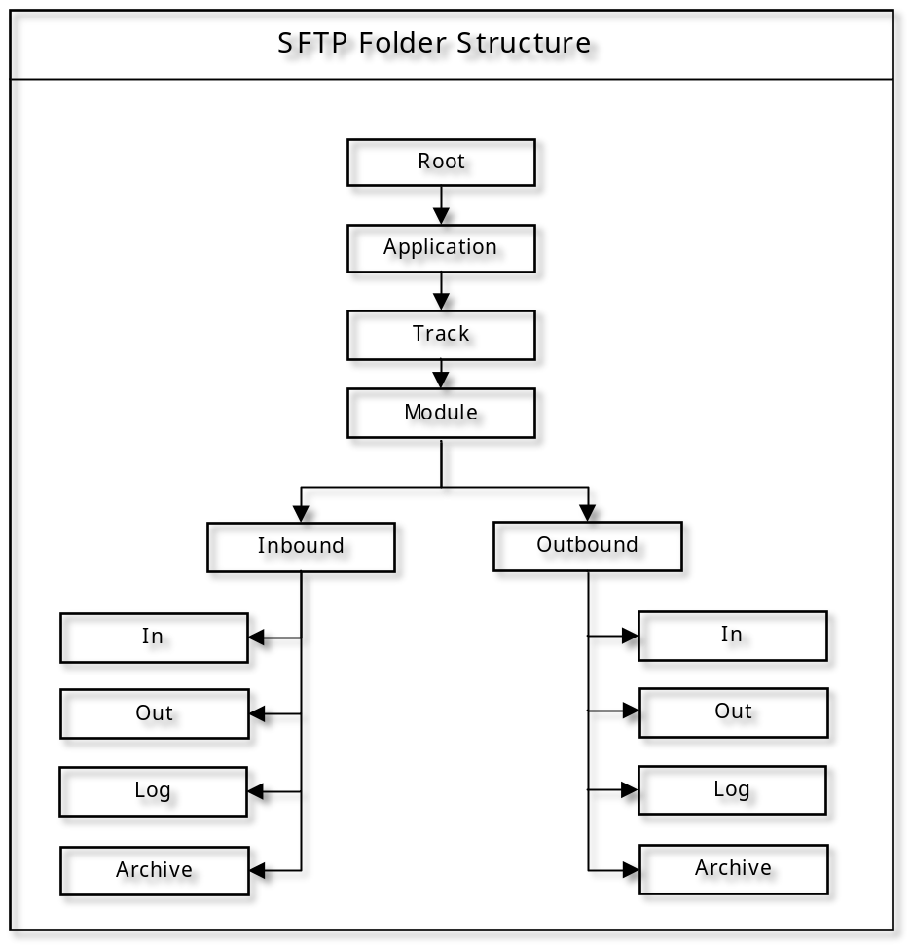
- Note: The folder structure is provided for reference purposes. The structure will be re-visited during the design phase
- Below is the Variable from folder structure diagram and its example.
Application : PSFT, GARPAC, KRONOS
Track : FINANCE, SCM
Module : GL, AR, AP

Naming Standards

Projects
They are used to group together similar artifacts which include integrations,
Connections, lookups and java libraries.

Object | Naming Convention | Example
Project | Project name must start with DGE followed by all words in InitCap. It Format: DGE <Module/ProjectPurpose> Integrations Project. |  | ADG Common Integrations Project  ADG Finance Integrations Project  ADG Procurement Integrations Project

Packages
Packages are used to group together integrations into logical units based on functionality. Every integration object should be assigned to a package. Packages are useful not only for organization and taxonomy but are also necessary to enable easy migration of all dependent components via the export/import feature.
Object | Naming Convention | Example
Packages | Package names must be all in lower case. Package names should use letters (a-z), numbers (0-9) and special characters (underscore <_> or hyphen <->). It must begin with a letter. It cannot be longer than 50 characters and must start with letters (A-Z).  Package names should follow this convention:  <organizationcode>.<3 char support area code>.<module name>.<submodule>  Packages are used to group together multiple related integrations, usually by functionality and module. |  | Format: <adg>.<fin>.<module>.<submodule> Example:  adg.fin.ap.invoices

Connections
Object | Naming Convention | Example
Connection Name | Connection Names should be meaningful descriptive that will help others find and understand this integration and should follow this convention:  <Organization code> <Application Name> Conn | ADG ERP Conn  ADG ATP Conn  ADG ERP Report SOAP Conn
Connection Identifier | Connection identifiers should be in upper case and follow this convention:  <ADG>_<Application Name>_CONN  Important Note: Connection Id must remain the same across environments and hence should not have any environment specific references. | ADG_ERP_CONN  ADG_ATP_CONN  ADG_ERP_REPORT_SOAP_CONN
Connection Description | Connection Descriptions should be in regular English. Descriptions should document details of the end system for which the connection is created and the scenarios/patterns for which the connection should be used.

Integrations
Integration objects are created for each integration flow implemented using Oracle Integration. The combination of Integration Identifier and Version must be unique within an OIC instance
Object | Naming Convention | Example
Integration Name | Integration Names can have letters (A-Z a-z), numbers (0-9), spaces ( ) and special characters  (underscore <_> or hyphen <->). It cannot be longer than 50 characters and must start with a letter. Integration Names must be in camel case and follow the convention:  Stand Alone integrations: <ADG>_<module name>_<desc>  Common integrations: <ADG>_CMN_<desc>  Wrapper for Schduled Integrations: <ADG>_<module name>_WRP_<desc> | Stand Alone:  ADG_FIN_PSFT_To_FAH_GL  Common:  ADG_CMN_FAH_To_ERP_GL  Wrapper: ADG_AP_WRP_CREATE_INVOICES
Integration Identifier | Integration identifiers should use letters (A-Z), numbers (0-9) and special characters (underscore <_> or hyphen <->). It cannot be longer than 32 characters and must start with letters (A-Z). Integration Identifiers must be all in upper case and follow this convention:  Stand Alone integrations: <ADG>_<module name>_<desc>  Common integrations: <ADG>_CMN_<Description>  Wrapper for Schduled Integrations: < ADG>_<module name>_WRP_<desc> | Stand Alone:  ADG_AP_CREATE_INVOICES  Common:  ADG_CMN_EMAIL_NOTIFICATION  Wrapper: ADG_AP_WRP_CREATE_INVOICES
Integration Description | Integration Descriptions should be in regular English. This section should also provide instructions on how to invoke the integration. Descriptions should convey the business purpose and functionality implemented by the integration. | This integration retrieves Exchange Rates from Refinitiv and transforms to FBDI format and uploads to SFTP. To invoke this integration, place the source file in location *location_path* and submit the scheduled integration.
Integration Version | Integration Versions are used to track major, minor and patch versions for integrations.  Integration Version is in the format major.minor.patch (xx.xx.xxxx). It cannot be longer than 10 characters. Version numbers should be numeric and sequential.  The initial version of a new integration should start with 1.00.0000  A major version update involves extensive changes to existing functionality and/or addition of new functions. Major version updates are also necessary when there are non-backward compatible changes to the interface contract which necessitate changes to interface consumers/source/target systems.  A minor version update involves minor enhancements to interface functionality. Minor version updates are backward compatible and interface consumers/source/target systems are not required to make any changes.  A patch version update is usually made for defect fixes applied to the current version of an integration or service.  Patch version updates are also backward compatible and interface consumers/source/target systems are not required to make any changes. | 1.00.0000
Messages | When defining messages (e.g. in a WSDL), the name of the message type should be in InitCamelCase and end with RequestMsg, ResponseMsg or FaultMsg | InvoiceRequestMessage LocationDetailsReponseMessage

Lookups
Object | Naming Convention | Example
Lookup Name | Names cannot be longer than 50 characters and must start with a letter.  Lookup names should be all in upper case and follow this convention:  <ADG>_<ModuleName or COMMON for Common Lookups>_<ElementName>_LKP | ADG_COMMON_INTERFACE_CONFIG _LKP  ADG_GL_DAILY_RATE_LKP
Lookup Description | Lookup Descriptions should be in regular English. Descriptions should document the purpose of the lookup, domain values mapped.
Lookup Column Name | Lookup Column name should follow below convention:  <Meaningful Name><Identifier> | A lookup “ADG_GL_DAILY_RATE_LKP” can have following column:  GLRateTypeCode

Integration Components and Activities
Object | Naming Convention | Example
Trigger  (For App Driven Integrations only) | ReceiveRequest | ReceiveRequest
Trigger (ERP)  (For Callback Integrations) | TriggerBusinessEvent | TriggerBusinessEvent
Scope | Scope_<Name describing the Scoped Tasks> | Scope_InvokeERPCloud,  Scope_UploadToSFTP
Variables | Starts with lv as prefix for variable names for local variable and if it is global variable gv  Local: lv_<MeaningfulName>  Global: gv_<MeaningfulName> | gv_flowId  lv_amount
Assign | Assign_<Name of what is being assigned> | Assign_InitialValuesToGlobalVaribales,  Assign_FlowId
Invoke | Invoke_<Connection>_<Optional:System>_<Operation> | Invoke_OracleCloudERP_UploadFBDI  Invoke_SOAP_OracleBIP_GetRates
Stage | Stage_<Name of what is being done> | Stage_WriteBIPResponse, Stage_ReadBIPResponse,
Terminate | Terminate_<reason of termination> | Terminate_Timeout, Terminat_EndOfProcess
Throw | Throw_<fault name> | Throw_ExceededMaxWaitTime
While | While_<Name describing the loop condition> | While_AllMsgsSent
File Name | Most of the cases, third party systems or internal systems or vendor dictates the name of interface files that must be sent to or are sent from the respective systems. Such data file name requirement will be captured in the respective solution design document and should be followed if provided. If no file name requirements are provided, the following format will be used -  <APP>_<MODULENAME>_<DESC>_<*TYPE>_<INSTANCEID>_<TIMESTAMP>.<extension>  APP - Source application ex: PSFT  MODULENAME - GL, AP, AR  DESC - Brief desc of RICE  TYPE – ERR for Error, SUCC for Success, WARN for Warning.  INSTANCEID – Insatance Id of Parent OIC service.  TIMESTAMP – In *YYYYMMDDHHMMSS.  *Use Type in scenarios such as sending files in Error or Success scenario’s. | PSFT_GL_RECON_WARN_2400019_20230510113845.csv  Use the below function to get Date in mentioned format.  xp20:format-dateTime (string (fn:current-dateTime() ), "[Y0001][M01][D01][H01][m01][s01]" )

OIC Integration Design Basic Guidelines
- Create one common shared connection for an end system and use this connection for all integrations that need to connect to that end system.
- For the integration runtime instance tracking, capture business identifiers that are unique and give a meaningful tracking name. This is necessary to help uniquely identify the integration run during monitoring or error administration.
- Avoid developing highly processing intensive integration flows, which take more than 300 seconds to complete end to end. The goal should be to decompose large complex flows into modular sub-flows focused on specific activities.
- All scheduler integration should be of Async or fire and forget type to avoid thread blocking. This will allow configuring multiple schedules.
- While creating Scheduled Jobs for processing files, cap the maximum number of files that can be processed in a single integration flow. If more files than the set limit are available for processing, call the same integration flow at the end of processing to resume processing the remaining files.
- Use Lookups to Externalize Configurable Parameters and Environment Specific values.
- Avoid hardcoding file paths, error codes and other dynamic values. Use lookups to derive dynamic values. Which will ease the code migration.
- All the DVM lookups should configure a default value in case the dvm look up fails.
- Avoid sending blank nodes while passing messages through multiple flows. This will reduce the payload size.
- Activation of Versions:
  - Integrations with different major versions can be active at the same time.
  - Integrations with the same major version, but a different minor version follow this rule:
    - Only one minor version can be active.
    - Activating the newer integration will automatically deactivate the currently active
  - Once development is finalized, clone the integration and set it as the default version.

High Volume Design Considerations
Below are the few payload and file processing limits need to consider while designing the OIC
- REST Adapter service limits
- Incoming structured message payload (JSON or XML) size must not exceed 50 MB
- Incoming content as raw bytes (application/octet-stream as content type) is limited to 1 GB.
- Incoming JSON attachments size is limited to 1 GB.
- SOAP Adapter service limits
- MTOM attachment (binary and non-binary content) size in Request and Response for SOAP Adapter is limited to 1 GB.
- Structured payload (XML) size in Request and Response is limited to 50 MB
The following table provides a recommended processing approach for different Interfaces:
Inbound  Interface | File size | Design Consideration
File based Integration (FTP) | <= 1 MB | - Read entire file possible directly from SFTP (Decompressed file only)  - Recommendation is to use FTP-Download file and then stage read entire file
File based Integration (FTP) | <= 10 MB | - FTP List file, FTP Download file and then Stage file read – Read file in segments  - Read entire file is also supported (Decompresses file only)
File based Integration (FTP) | > 10MB and  < 1 GB | - FTP List file, FTP Download file and then Stage file read – Read file in segments
File based Integration (FTP) | > 1 GB | - Files to be uploaded in Object storage manually or via REST API (maximum file size 50 GB)  - ADW/ATP standard API (DBMS_CLOUD) to load data from object storage to Database. Database tables need to be created the same as the file format placed in object storage. The standard API directly pushes data from object storage to database table.
Rest Adapter | <= 1 MB | - Data be received as structured  request payload
REST Adapter | <= 10 MB | - Data be received as structured  request payload
REST Adapter | > 10MB and  < 1 GB | - Data can be sent as a file attachment  - Write the attachment in Stage file activity  - Read the file in segments and process further

Error Handling Guidelines
- Wherever applicable, scope should be used, and faults must be handled within it.
- Handle Global fault handlers to catch runtime system faults.
- Oracle Integration Cloud Service provides "Global Fault Handler" to catch faults in orchestrated integration. If an error is thrown at any stage in the integration flow, it will be captured by the Global Fault and a notification email will be sent out.
- The email IDs to which the notification is sent should be configured in a common Lookup. The Lookup will contain the RICEID of the integrations and the corresponding email IDs.

Common Integration User
Environment | Service account name (SAAS) | Email ID
Non-Prod
Production
- The common user accounts created ERP and OIC should follow below naming Convention
- This user should be present in OIC instance and ERP Cloud Application with required roles for integrations to run.

Open and Closed Issues

Open Issues
ID | Issue | Responsibility | Target Date

Closed Issues
ID | Issue | Resolution | Responsibility | Target Date | Closed Date

